Read chapter 8 and use the following questions as **PRACTICE** for your online listening/reading evaluations found in TEAMS –complete these questions on scrap paper and check your answers on the following page.

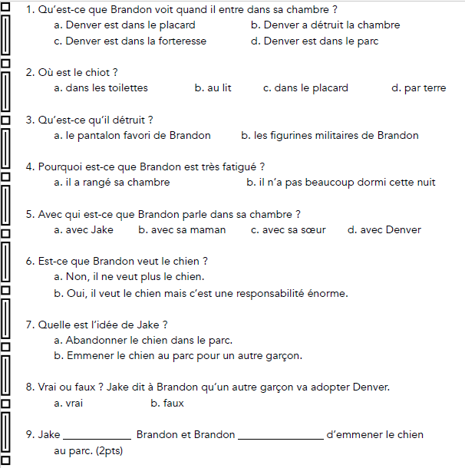

Scroll down for answers!

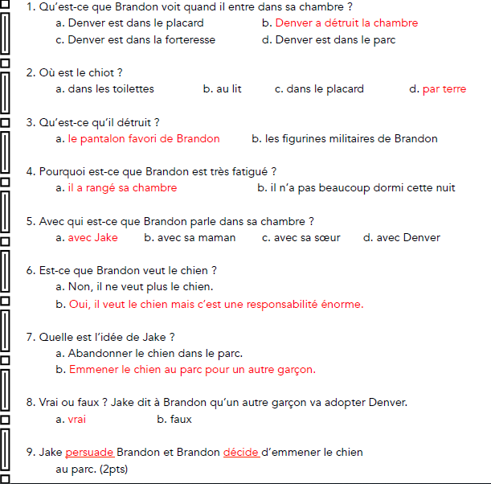

Scroll down for writing practice-see how well you can do!

For practice-write down a proper response in French then check your answers on the following page.

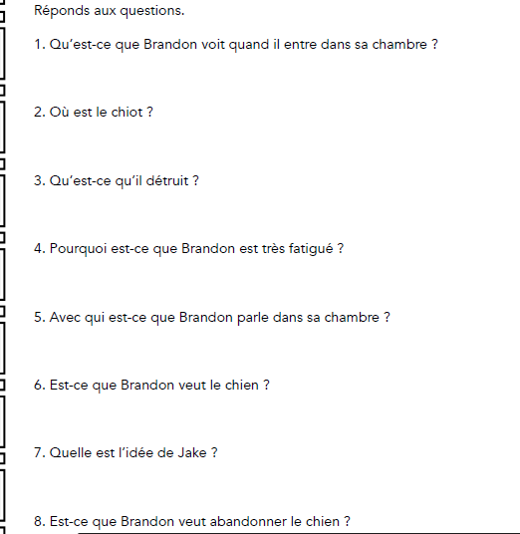

Scroll down for answers.

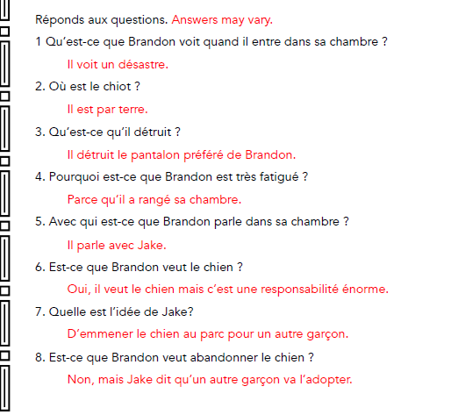

HOW DID YOU DO??? Email me with any comprehension questions ☺

NOW you are ready to take your listening and multiple choice quizzes on TEAMS. You will find the listening portion on my website.